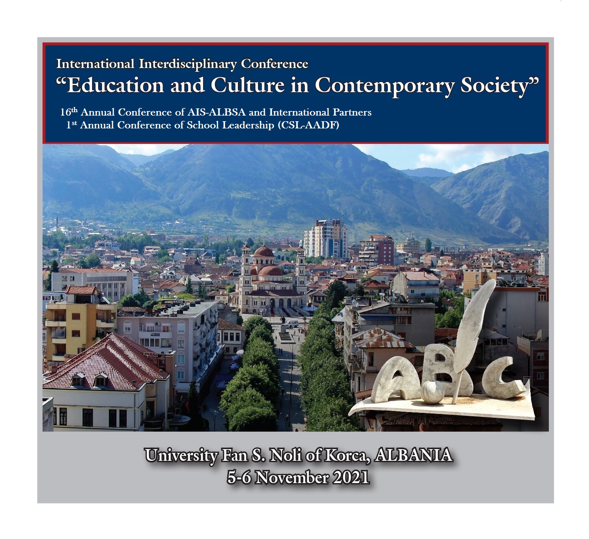

Abstract Submission Form

International Interdisciplinary Conference:
“Education and Culture in Contemporary Society”

16th Annual Int. Conference of AIS-ALBSA and Other Partners
1st Annual Conference of School Leadership (CSL – AADF)

Co-presence, Online, or Hybrid
University Fan S. Noli of Korca, Albania
5-6 November 2021

Please, fill out the Abstract Submission Form (ASF) and send it to the Conference secretary: E-mail: korca.conf.2021@gmail.com
(for the deadlines, and more details you can see: https://www.sociology.al/en/conferences/call-papers (English)
https://www.sociology.al/sq/konferenca/thirrje-p%C3%ABr-pjes%C3%ABmarrje (shqip)

Please, do not use the capital letters:
1st Author’s name and surname
University or Institution
Country
E-mail address:
Mobile:
2nd author’s name, surname:
University or Institution:
Country:
E-mail address:
3rd author’s name, surname:
University or Institution:
Country:
E-mail address:
Thematic Session (CSL-ST14):
SSL. Annual Conference of School Leadership (CSL - AADF)
TS01. Culture, Arts, Public Sphere and Communication
TS02. Population, Migration and Diaspora
TS03. Education and Sport
TS04. Politics, Democracy, Integration and Law
TS05. Religion, Collective Behavior and Social Movements
TS06. Marriage, Family, Welfare, Social Policy and Community
TS07. Childhood, Youth, Leisure, Aging and Gender
TS08. Work, Professions and Organization
TS09. Comparative, Historical, Regional, Global and Future Studies
TS10. Security, Public Health, Deviance and Social Control
TS11. Ethnic Relations, Nationalism, Human Rights
TS12. Environment, Economy, Tourism and Development
TS13. Science, Technology, Digitalization and Innovation
TS14. Student’s Section [Education and Culture in student’s perspective]
Abstract Title (not more than 15 words):
Abstract, no longer than 250-300 words (including: research questions, theoretical framework and methodology, findings/results and conclusions)
Keywords (4-6 words):
Note: All forms of presentations can be used (as conditioned by Covid-19 Pandemic)
Presentation (specify):
1. Oral/Power Point Presentation (distributed paper; Poster Presentation); 2. On-line presentation/videoconference
If you are interested to publish the full paper as scientific article in the International Journal “Social Studies” (in English or Albanian language), please go to: https://www.sociology.al/sq/revista-studime-sociale-kriteret-e-botimit (for articles in Albanian), or: https://www.sociology.al/en/social-studies-author%E2%80%99s-guide (for articles in English)

Please, don’t hesitate to contact the conference secretary: korca.conf.2021@gmail.com; secretary@sociology.al;
Or, the Coordinator of Annual Int. Conferences (since 1999): lsokoli53@gmail.com

